|  |  |
| --- | --- |
|  | 6 P O Box 5711 |
| BBST1 214787  *ENTERPRISEFINANCIALSOLUTION (PTY)LTD  443 SALFIN DEVELOPMENT CARNIVAL GREEN | Weltevreden Park , 1709  **Street Address** Mybranch  Forum 1, 4th Fl, 33 Hoofd Str, Braampark  **Universal Branch Code** 250655  9 fnb.co.za  **Lost Cards** 087-575-9406 |

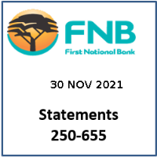**Account Enquiries** 087-736-2247 BOKSBURG**Fraud** 087-311-8607 1478

|  |  |  |  |  |
| --- | --- | --- | --- | --- |
| Branch Number | Account Number | Date | DDA AA/48/BV/KY/KY/BF/B9/C6/CK/N | FN |

# MAHLAULEA6@GMAIL.COM

|  |  |  |
| --- | --- | --- |
| **Customer VAT Registration Number** Not Provided **Bank VAT Registration Number** 4210102051 |  | **Gold Business Account : 62911182989**  Tax Invoice/Statement Number : 1  Statement Period : 31 August 2021 to 30 September 2021 **Statement Date : 30 September 2021** |
| **Statement Balances** | **Bank Charges** | **Interest Rate** |

|  |  |  |  |  |  |  |  |  |  |
| --- | --- | --- | --- | --- | --- | --- | --- | --- | --- |
| |  | | --- | | Opening Balance  Closing Balance | | # Inclusive of VAT @ 15.00%  Total VAT (ZAR) | | |  | | --- | | Service Fees  Cash Deposit Fees  Cash Handling Fees  Other Fees | | |  |  | | --- | --- | | Credit Rate** | Tiered | | Debit Rate(Non-NCA) | 7.00% | |

**Transactions in RAND (ZAR)**

|  |  |  |  |  |  |  |  |
| --- | --- | --- | --- | --- | --- | --- | --- |
| **Date** |  |  |  | **Description** | **Amount** | **Balance** | **Accrued Bank**  **Charges** |
| 23 Sep  23 Sep | Opening Balance |  |  |  | 560,784,4.35 | 560780. 00 |  |
|  | Dr.Int.Rate 7,00000 |  |  |  | 0.00 | 4.35 |  |

|  |  |  |  |
| --- | --- | --- | --- |
| 620 | 62911182989 | 2021/09/30 | GOLD BUSINESS ACCOUNT |

**Closing Balance 560,780,00Cr**

**Turnover for Statement Period**

|  |  |  |  |
| --- | --- | --- | --- |
|  | No. Credit Transactions 1 | 560,780,00Cr |  |
|  | No. Debit Transactions 1 | 4.35Dr |  |
| **Please contact us within 30 days from your statement date, should you wish to query an entry on this statement (incl. card transactions done during this statement period, but not yet reflecting). Should we not hear from you, we will assume that you have received the statement and that it is correct.** | | | |

For more information on your Pricing Option, please contact us or visit our website. **For the latest Credit Rates on product, please go to fnb.co.za

First National Bank - a division of FirstRand Bank Limited. Registration Number 1929/001225/06. An Authorised Financial Services and Credit Provider (NCRCP20).

On 24 July 2020, the Prime Lending Rate changed to 7.00%. This may impact the rate on any of your credit facilities.

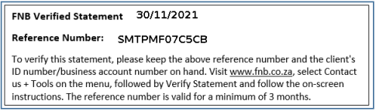

**Page 1 of 1**

Delivery Method E1 R05

EN/EM/WV/DDA AA

620

467857